
ARBORICULTURE I

Module 2

Observing trees
  - From careful field notes to a clear tree report

Course information | Value
Course level | Beginner
Nominal module time | 12 hours
Delivery | Self-paced distance education
Fieldwork | Ground-level observation only

Pilot edition 3.0 | July 2026

How to use this module
Module 1 introduced arboriculture, safe beginner limits, basic tree records and urgent warning signs. This module does not repeat those lessons. It helps you become a more accurate observer and turn your evidence into a useful report.
- Study one unit at a time.
- Use the Tree Observation Worksheet while you are beside the tree.
- Write what you can see, hear, feel safely or measure. Do not guess.
- Use Unknown when something cannot be seen or confirmed.
- Use your worksheet and photographs to complete the Tree Report Form.
- Upload only the work marked Assessment — upload required.
Important safety rule: Observe from the ground. Do not climb, cut, break or pick tree parts for this module. Do not enter an unsafe area to obtain a photograph. If an obvious danger is present, move away, keep others away where practical and tell the person responsible for the site.

Module aim
To help you observe one tree systematically, record reliable evidence and prepare a clear tree report without claiming more than the evidence shows.

Learning outcomes
- prepare a safe and repeatable tree observation;
- observe the site, crown, branches, trunk, base and visible root area in a consistent order;
- record useful photographs, measurements and field notes;
- use Tropical Trees and Tree family names as reference documents;
- separate observation, possible meaning, recommended action and uncertainty;
- complete the KETSO Tree Observation Worksheet;
- complete the KETSO Tree Report Form for one individual tree.

Reference documents
You will use two separate KETSO references during the seven-tree assignment. Open them online before fieldwork or save them to your device when internet access is available.
Tropical Trees: Open the 71-tree reference document
Use this document to choose a numbered candidate tree and compare the available profile with the real tree.
Tree family names: Open the tree-family reference document
Use this document to copy the family name only when your candidate tree is listed there. Write Unknown when the family is absent or unclear.
Reference limit: These documents help you organise a candidate identification. They do not prove a species or family from photographs. Record Likely, Possible or Unknown and ask for human review when evidence conflicts.

Assessment at a glance
Item | What you submit | Marks
Quiz | 15 automatically checkable answers | 15
Seven-tree field evidence | Seven worksheets and 28 photographs | 55
Tree report | One detailed report based on one of the seven trees | 30

Pass requirement: A total score of 70% is required. Unsafe field behaviour, invented observations or a serious mismatch between evidence and conclusions leads to Revise.

  - Unit 1

Observe before you interpret
Estimated time: 1 hour
A useful tree report begins with an observation. An observation is something you can directly notice or measure. It is not yet a diagnosis.
Stage | Question | Example
1. Observation | What can I directly see or measure? | A vertical crack is visible on the lower trunk.
2. Possible meaning | What might this mean? | The crack may be connected with recent damage.
3. Recommended action | What should happen next? | Ask the site manager to arrange an experienced review.
4. Uncertainty | What is still not known? | The depth and internal condition are Unknown.

Use careful evidence words
Word | When to use it
Unknown | You do not have enough information to answer.
Possible | The evidence may fit, but other explanations are also reasonable.
Likely | Several observations support the explanation and no important observation conflicts.

Professional limit: A beginner field report records visible evidence. It does not confirm internal decay, structural safety, disease, insect identity or the need to remove a tree.

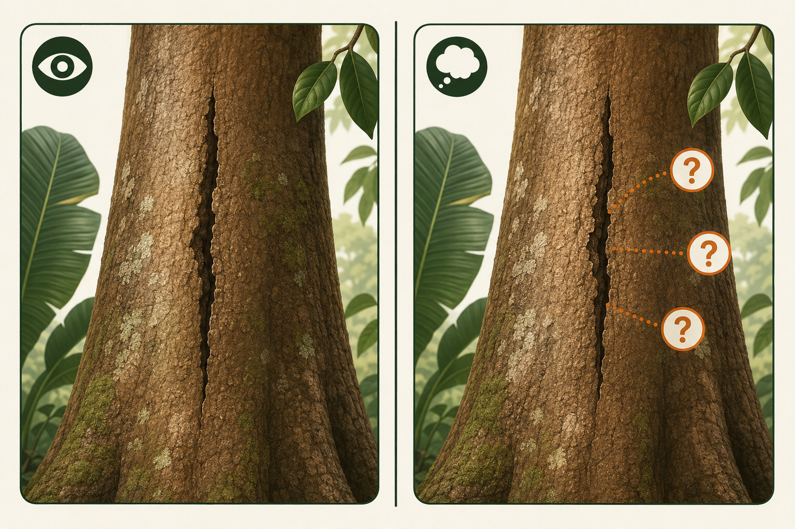
Figure 1. First record what is visible. Only then consider what it may mean.

Self-reflection 1: Change the sentence
Practice — no upload

Rewrite each claim as a direct observation. Then add a separate possible meaning.
- The tree is dangerous.
- The roots are sick.
- The leaves have a disease.
Ask yourself: Which words describe evidence, and which words claim a cause or diagnosis?
  - Unit 2

Prepare the observation
Estimated time: 1 hour
Good preparation makes the record repeatable. Another person should be able to locate the same tree and understand the conditions at the time of your visit.

Before approaching the tree
- Ask permission from the owner, school, farm, community group or site manager when needed.
- Look for traffic, unstable ground, fire, flooding, aggressive animals, hanging branches and electricity lines.
- Choose a safe observation route around the tree. Stay outside any unsafe area.
- Prepare your phone or camera, worksheet, pen, measuring tape or a safe estimation method.

Identify this individual tree
- Give the tree a unique code, such as SCHOOL-03 or FARM-A12.
- Record the place name and useful landmarks.
- Add a map pin or GPS position only when available.
- Record the observer, date and time.
- Record recent weather or a known event only when it may affect what you see.

Self-reflection 2: Can another person find it?
Practice — no upload

Choose one nearby tree. Write a location description without using only ‘near my house’. Ask another person whether the description would help them find the same tree.
Do not invent precision: If you do not have GPS, use clear landmarks. If you estimate a measurement, label it Estimated and explain the method.

  - Unit 3

Use a consistent observation route
Estimated time: 2 hours
Observe the same areas in the same order. This reduces the chance that you forget an important part. Walk only where it is safe and permitted.
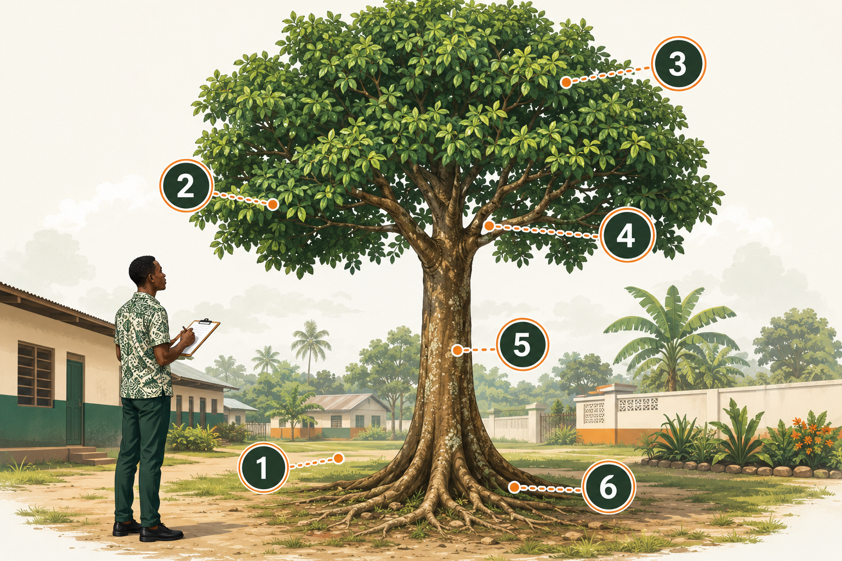
Figure 2. A six-part observation route around one tropical tree.
Observation area | Look for and record
1. Site context | Land use, people, paths, buildings, drains, crops, soil surface and recent disturbance.
2. Whole tree | Overall form, lean, crown balance and relationship to the space around it.
3. Crown and leaves | Leaf amount, colour differences, bare areas, dead twigs and uneven growth.
4. Branches | Broken, dead, hanging or crossing branches; branch attachments visible from the ground.
5. Trunk | Number of stems, lean, cracks, wounds, holes, loose bark, fungi, attachments and visible insects.
6. Base and visible roots | Root flare, exposed or cut roots, changes in soil level, erosion, compaction and waterlogging.

Describe position and extent
- Position: lower trunk, north-facing side if known, above the path, or near the base.
- Amount: one branch, several branches, a small patch, about half of the crown.
- Size: measured or estimated length, width, height or circumference.
- Change: new, increasing, unchanged or Unknown. Only claim change if there is earlier evidence.

Self-reflection 3: Make notes specific
Practice — no upload

Improve this note: ‘The tree looks bad.’ Write four separate notes describing the crown, trunk, base/root area and site. Use Unknown where evidence is missing.

  - Unit 4

Collect evidence that supports your notes
Estimated time: 1.5 hours
Photographs and measurements help another person understand your notes. They do not replace written observations.

Required photograph set
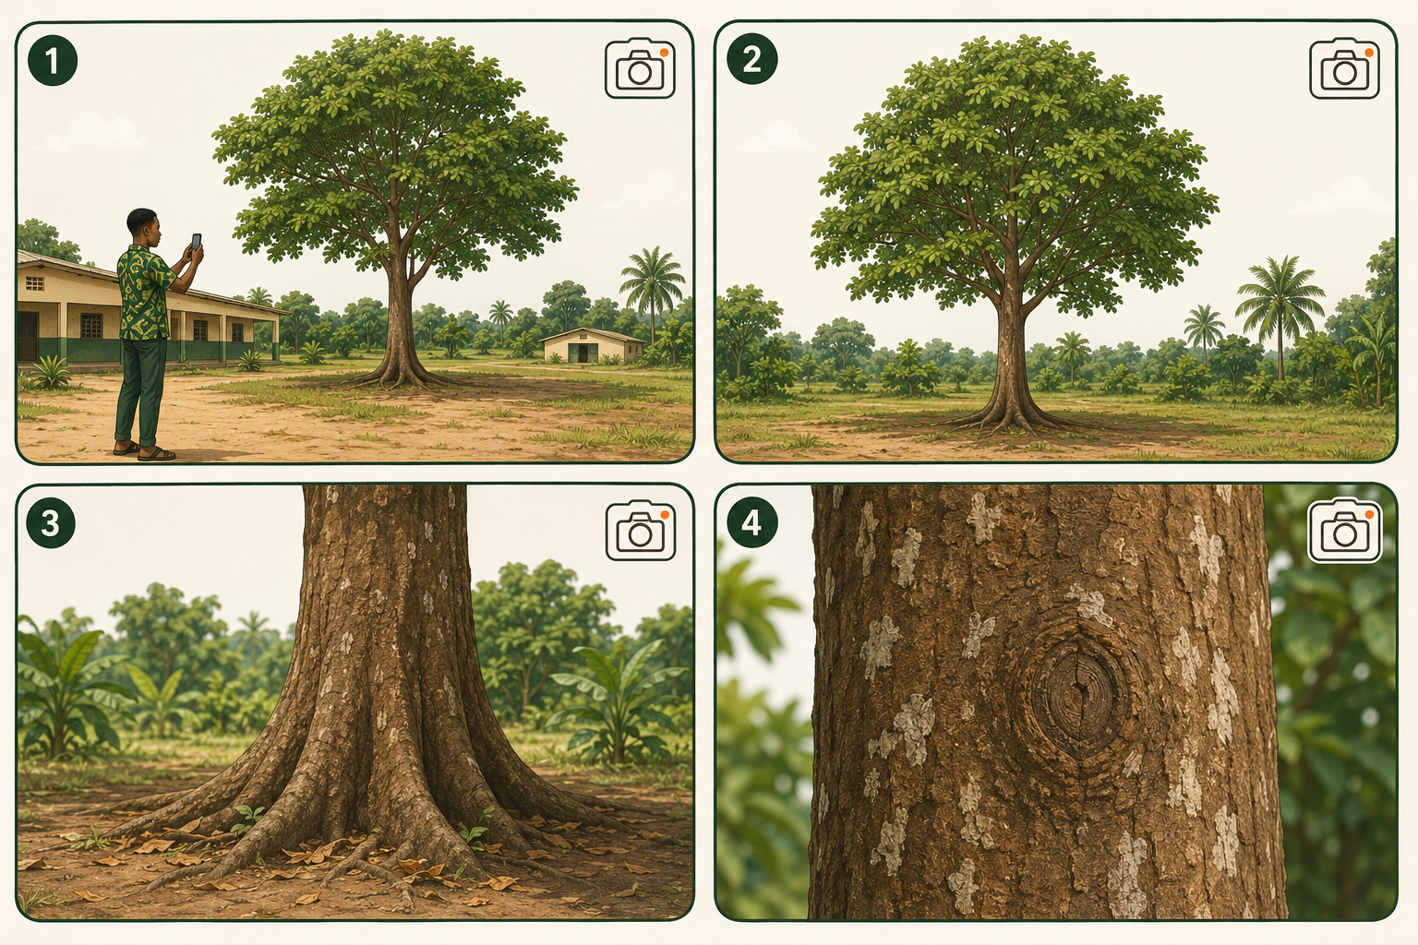
Figure 3. Take four evidence photographs for each of your seven trees.
Photo | Purpose
1. Site context | Shows the tree in relation to paths, buildings, crops and nearby use.
2. Whole tree | Shows the full form from a safe distance.
3. Trunk and base | Shows the lower trunk, root flare and surrounding ground.
4. Detail | Shows one important feature with enough context to locate it on the tree.

- Give every photograph a number and short caption.
- Take a wider view before a close view.
- Use an object of known size only when it can be placed safely and does not hide the feature.
- Do not use a close-up photograph as proof of the condition of the whole tree.
- Do not alter photographs in a way that changes the evidence.

Simple measurements
Measure | Possible beginner method | Record
Trunk circumference | Tape around the trunk at a stated height. | Value, unit and measurement height.
Crown width | Estimate or measure the ground distance beneath the widest crown spread. | Value, unit and method.
Tree height | Use a safe estimation method or write Unknown. | Estimated value, unit and method.
Feature size | Use a ruler or safe visual scale. | Length or width, unit and photo number.

Self-reflection 4: Evidence check
Practice — no upload

Review five tree photographs on your phone. For each image, state what it proves, what it does not prove and whether a wider or closer image is needed.
  - Unit 5

Complete the Tree Observation Worksheet
Estimated time: 2 hours
The worksheet is your field record. Complete it beside the tree. Short, accurate notes are more useful than long guesses.

Field method
- Complete Part A before you start the detailed observation.
- Use Part B to check each observation area in order.
- Link important notes to photograph numbers or measurements.
- Complete Part C only after you have finished looking at the tree.
- Before leaving, check for blank fields. Write Unknown or Not observed and explain why.
Keep the stages separate: Part B is for direct observations. Part C is for possible meaning, recommended action and uncertainty. Do not mix them.

Assessment 1: Seven-tree field observation
Assessment — upload required

- Open Tropical Trees and choose seven different numbered candidate trees that may grow in your area.
- Copy each tree number and scientific name exactly as written in Tropical Trees.
- Check Tree family names. Copy the family only when the candidate tree is listed. Otherwise write Unknown.
- Find those seven trees in real life. If a chosen tree cannot be found, choose another tree from the document.
- Do not confirm a species from one feature. Compare leaves, bark, crown, flowers and fruit when available. Record the name as Possible when evidence is incomplete.
- Complete one copy of Appendix A for each tree: seven worksheets in total.
- For each tree, submit four photographs: site context, whole tree, trunk and base, and one useful detail. Submit 28 photographs in total.
- Use the same tree code on its worksheet and all four photographs.
- Include at least one measured or clearly labelled estimated value for each tree.
- Record Unknown or Not observed where evidence is unavailable.

Quality check before upload
- Each of the seven tree codes is unique and each location is repeatable.
- Every statement in Part B is directly observable.
- Important notes link to a photograph or measurement.
- Possible meaning is cautious and does not claim a diagnosis.
- The limitations are honest.
  - Unit 6

Turn field evidence into a tree report
Estimated time: 1.5 hours
A tree report is a short, organised record for the person responsible for the site. It should make the evidence and next step easy to understand.

Report sequence
- Identify the tree, observer, date and reason for the report.
- Summarise the site and the main direct observations.
- State possible meaning only where evidence supports it.
- Recommend a proportionate action.
- Name the person or group responsible for follow-up.
- Record priority, review date, limitations and Unknowns.

Choose a proportionate action
Action | Use when
No action now | No follow-up need is supported by the present observations.
Monitor | A feature or change should be checked again at a stated date.
Routine care | A normal care task is supported and can be assigned safely.
Restrict access | People should be kept away from an obvious possible danger while help is arranged.
Experienced review | The evidence or uncertainty is beyond a beginner’s competence.

Priority is not a diagnosis
- Immediate: act now because people may be exposed to an obvious possible danger.
- Soon: arrange follow-up within a stated short period.
- Routine: include the action in normal care or monitoring.

Assessment 2: Tree report
Assessment — upload required

- Choose one of your seven observed trees and complete Appendix B for that tree.
- Use only evidence from your worksheet and photograph set.
- Explain one main observation, its possible meaning, the recommended action and what remains uncertain.
- Name a realistic responsible person or group and a review date.

Module 2 quiz
Assessment — upload required

Choose one answer for each question. The quiz can be marked automatically. The answer key is in the separate KETSO Module 2 AI Review Guide.

1. Which sentence is a direct observation?
☐ A. The tree is dangerous.
☐ B. A crack is visible on the lower trunk.
☐ C. The roots are diseased.
☐ D. The tree must be removed.

2. Why are observation and possible meaning written separately?
☐ A. To make the report longer.
☐ B. To hide uncertainty.
☐ C. To separate evidence from interpretation.
☐ D. To avoid photographs.

3. When should you write Unknown?
☐ A. When evidence is missing or cannot be confirmed.
☐ B. When you dislike the tree.
☐ C. When the answer is obvious.
☐ D. When a photo is clear.

4. What does Possible mean?
☐ A. The cause is confirmed.
☐ B. The evidence may fit, but other explanations remain.
☐ C. No evidence exists.
☐ D. The tree is safe.

5. What makes a location repeatable?
☐ A. ‘Near my house’.
☐ B. A tree name only.
☐ C. Clear place details and useful landmarks.
☐ D. One close-up photo.

6. Which order matches the observation route?
☐ A. Site, whole tree, crown, branches, trunk, base and roots.
☐ B. Fruit, price, owner, age, height, soil.
☐ C. Trunk, diagnosis, pruning, roots, sale.
☐ D. Leaves only.

7. Why record the position and size of a feature?
☐ A. To make evidence specific and findable.
☐ B. To prove the cause.
☐ C. To replace a photo.
☐ D. To identify every species.

8. Which four photos are required for every tree?
☐ A. Four close-ups.
☐ B. Site, whole tree, trunk and base, detail.
☐ C. Leaves, flowers, fruit, seeds only.
☐ D. Observer, road, building, sky.

9. Why is one close-up not enough?
☐ A. It cannot show where the feature is on the whole tree.
☐ B. It always changes colour.
☐ C. Phones cannot focus.
☐ D. Close-ups are unsafe.

10. What belongs with an estimated measurement?
☐ A. Only a number.
☐ B. Value, unit, method and the word Estimated.
☐ C. A diagnosis.
☐ D. The owner’s opinion.

11. What is the worksheet mainly for?
☐ A. Direct field evidence recorded beside the tree.
☐ B. Final species certification.
☐ C. Advertising.
☐ D. A pruning order.

12. What is the Tree Report Form mainly for?
☐ A. Organising evidence, possible meaning, action and uncertainty.
☐ B. Replacing all worksheets.
☐ C. Confirming internal decay.
☐ D. Giving legal permission.

13. When is Experienced review appropriate?
☐ A. When evidence or uncertainty is beyond beginner competence.
☐ B. For every healthy leaf.
☐ C. Only after cutting a branch.
☐ D. Never.

14. Why name a responsible person or group?
☐ A. So follow-up has clear ownership.
☐ B. To blame someone.
☐ C. To identify the species.
☐ D. To improve the photograph.

15. Which is a valid limitation?
☐ A. The upper crown could not be seen clearly from the ground.
☐ B. The hidden wood is definitely sound.
☐ C. The tree can never fail.
☐ D. The disease is confirmed without evidence.

Final module assignment: Find seven trees
Assessment — upload required

Your task: Use Tropical Trees as your 71-tree search list and Tree family names as a supporting family reference. Find seven listed trees in real life, observe them safely, take four evidence photographs of each tree and complete one worksheet for each tree.

Tropical Trees: Open the 71-tree reference document
Tree family names: Open the tree-family reference document
Step | What to do
1 | Select seven different numbered candidate trees from Tropical Trees.
2 | Find a real example of each tree in a permitted and safe place.
3 | Give each tree a unique code: M2-T01 to M2-T07.
4 | Copy its tree number and scientific name from Tropical Trees. Copy its family from Tree family names only when listed.
5 | Compare the real tree with the reference. Record the identification as Likely, Possible or Unknown.
6 | Take four photographs of each tree: site context, whole tree, trunk and base, and one useful detail.
7 | Complete one Tree Observation Worksheet for each tree.
8 | Choose one of the seven trees and complete one detailed Tree Report Form.
9 | Upload the quiz, My seven trees page, seven worksheets, 28 photographs and one Tree Report Form.

This continues in every module: At the end of each Arboriculture I module, you will find and document seven more trees from Tropical Trees. Do not reuse a tree unless the module instructions specifically allow it.

My seven trees
Assessment — upload required

Complete this plan before fieldwork. The candidate identification may change after observation. Do not change the wording copied from a reference. Use Unknown when a family is not listed or when the evidence is insufficient.
Tropical Trees: Open the 71-tree reference document
Tree family names: Open the tree-family reference document
Code | No. in Tropical Trees | Scientific or listed name | Family or Unknown | ID confidence
M2-T01 |  |  |  | Unknown / Possible / Likely
M2-T02 |  |  |  | Unknown / Possible / Likely
M2-T03 |  |  |  | Unknown / Possible / Likely
M2-T04 |  |  |  | Unknown / Possible / Likely
M2-T05 |  |  |  | Unknown / Possible / Likely
M2-T06 |  |  |  | Unknown / Possible / Likely
M2-T07 |  |  |  | Unknown / Possible / Likely

Source and evidence notes
Names that were absent, unclear or conflicting State the tree code and write what still needs human review.

Appendix A: KETSO Tree Observation Worksheet
Assessment — upload required

Make seven copies of this worksheet and complete one beside each tree. Record direct observations in Part B. Do not diagnose causes.

Part A: Observation details
A1. Tree code Use a code that identifies only this tree.

A2. Reference identity Tropical Trees number; scientific or listed name; family from Tree family names or Unknown; confidence: Likely, Possible or Unknown.

A3. Observer, date and time

A4. Repeatable location Place and landmarks; map pin or GPS only if available.

A5. Permission and site contact Owner, school, farm, community group or site manager.

A6. Reason for observing this tree

A7. Conditions during the visit Weather, visibility and any recent event known from reliable information.

A8. Safety check Hazards seen, safe route used and any area not entered.

Appendix A: Tree Observation Worksheet

Part B: Direct observations
B1. Site context Land use, people, paths, buildings, drains, crops, soil surface and disturbance.

B2. Whole tree Overall form, lean, crown balance and available space.

B3. Crown and leaves Amount, colour differences, bare areas, dead twigs and uneven growth.

B4. Branches Broken, dead, hanging or crossing branches and visible attachments.

Appendix A: Tree Observation Worksheet

Part B: Direct observations continued
B5. Trunk Number of stems, lean, cracks, wounds, holes, bark, fungi, attachments and visible insects.

B6. Base and visible roots Root flare, exposed or cut roots, soil level, erosion, compaction and waterlogging.

B7. Measurements or estimates Record value, unit, method and whether measured or estimated.

B8. Change over time New, increasing, unchanged or Unknown. State the earlier evidence used.

Appendix A: Tree Observation Worksheet

Part C: Evidence, meaning and next step
C1. Photograph list and captions Site context, whole tree, crown, trunk/base and detail.

C2. Main observation State the most important direct observation.

C3. Possible meaning Use Possible, Likely or Unknown and explain the evidence.

C4. Recommended action No action now, Monitor, Routine care, Restrict access or Experienced review.

C5. Uncertainty and limits What could not be seen, measured or confirmed?

C6. Final field check What should be checked again before the report is completed?

Appendix B: KETSO Tree Report Form
Assessment — upload required

Prepare this report after fieldwork. Use the evidence in Appendix A. Keep it short enough for the responsible person to use.

1. Report details
Tree code and location

Observer and observation date

Report date

Reason for report

Tree name Common or scientific name if known; otherwise write Unknown. Add confidence if relevant.

Appendix B: Tree Report Form

2. Evidence summary
Site context Only information relevant to understanding this tree.

Main direct observations Summarise crown, branches, trunk, base/root area and important measurements.

Photograph references List the photo numbers that support the main observations.

Change from earlier evidence State the evidence or write Unknown.

Appendix B: Tree Report Form

3. Meaning, action and uncertainty
Possible meaning Use Possible, Likely or Unknown. Do not claim an unconfirmed diagnosis.

Recommended action and reason Link the action directly to evidence.

Priority Immediate, Soon or Routine. Explain why.

Responsible person or group

Review date

Limits and Unknowns State what this beginner report cannot confirm.

Appendix C: Assessment checklist
Use this checklist before uploading your work.
Check | Yes / revise
I used one unique tree code in the worksheet, photographs and report.
The location is clear enough to find the same tree again.
My field notes describe direct observations.
My main observations link to photographs or measurements.
Every estimate is labelled and includes a method.
I separated observation, possible meaning, action and uncertainty.
I used Unknown where evidence was missing.
I did not claim an internal condition, disease or final safety decision.
My recommended action is proportionate to the evidence.
I named the person or group responsible for follow-up.
I completed the Module 2 quiz.
I completed seven worksheets and labelled 28 photographs.
I followed the ground-level safety limits.

Final self-reflection: What did you notice on the second careful look that you missed on the first look? What will you do differently during your next tree observation?

